**DAILY ONLINE ACTIVITIES SUMMARY**

|  |  |  |  |  |  |  |  |  |
| --- | --- | --- | --- | --- | --- | --- | --- | --- |
| **Date:** | **09/06/2020** | | | | | **Name:** | **Pratibha Shetti** | |
| **Sem & Sec** | **IV sem & B section** | | | | | **USN:** | **4AL18CS062** | |
| **Online Test Summary** | | | | | | | | |
| **Subject** | | **-** | | | | | | |
| **Max. Marks** | | **30** | | **Score** | | | **-** | |
| **Certification Course Summary** | | | | | | | | |
| **Course** | **Cyber Security** | | | | | | | |
| **Certificate Provider** | | | **Greatlearning academy** | | **Duration** | | | **7 hours** |
| **Coding Challenges** | | | | | | | | |
| **Problem Statement1:** Write a C Program to rotate the matrix by K times. | | | | | | | | |
| **Status: Executed** | | | | | | | | |
| **Uploaded the report in Github** | | | | | **YES** | | | |
| **If yes Repository name** | | | | | <https://github.com/pratibhashetty-123/Lockdown-coding-java>  <https://github.com/pratibhashetty-123/Lockdown-coding-for-C> | | | |
| **Uploaded the report in slack** | | | | | **YES** | | | |

Online Test Summary: No internals conducted today.

Online Certification Course Summary: In today’s session I have learnt about cryptography.

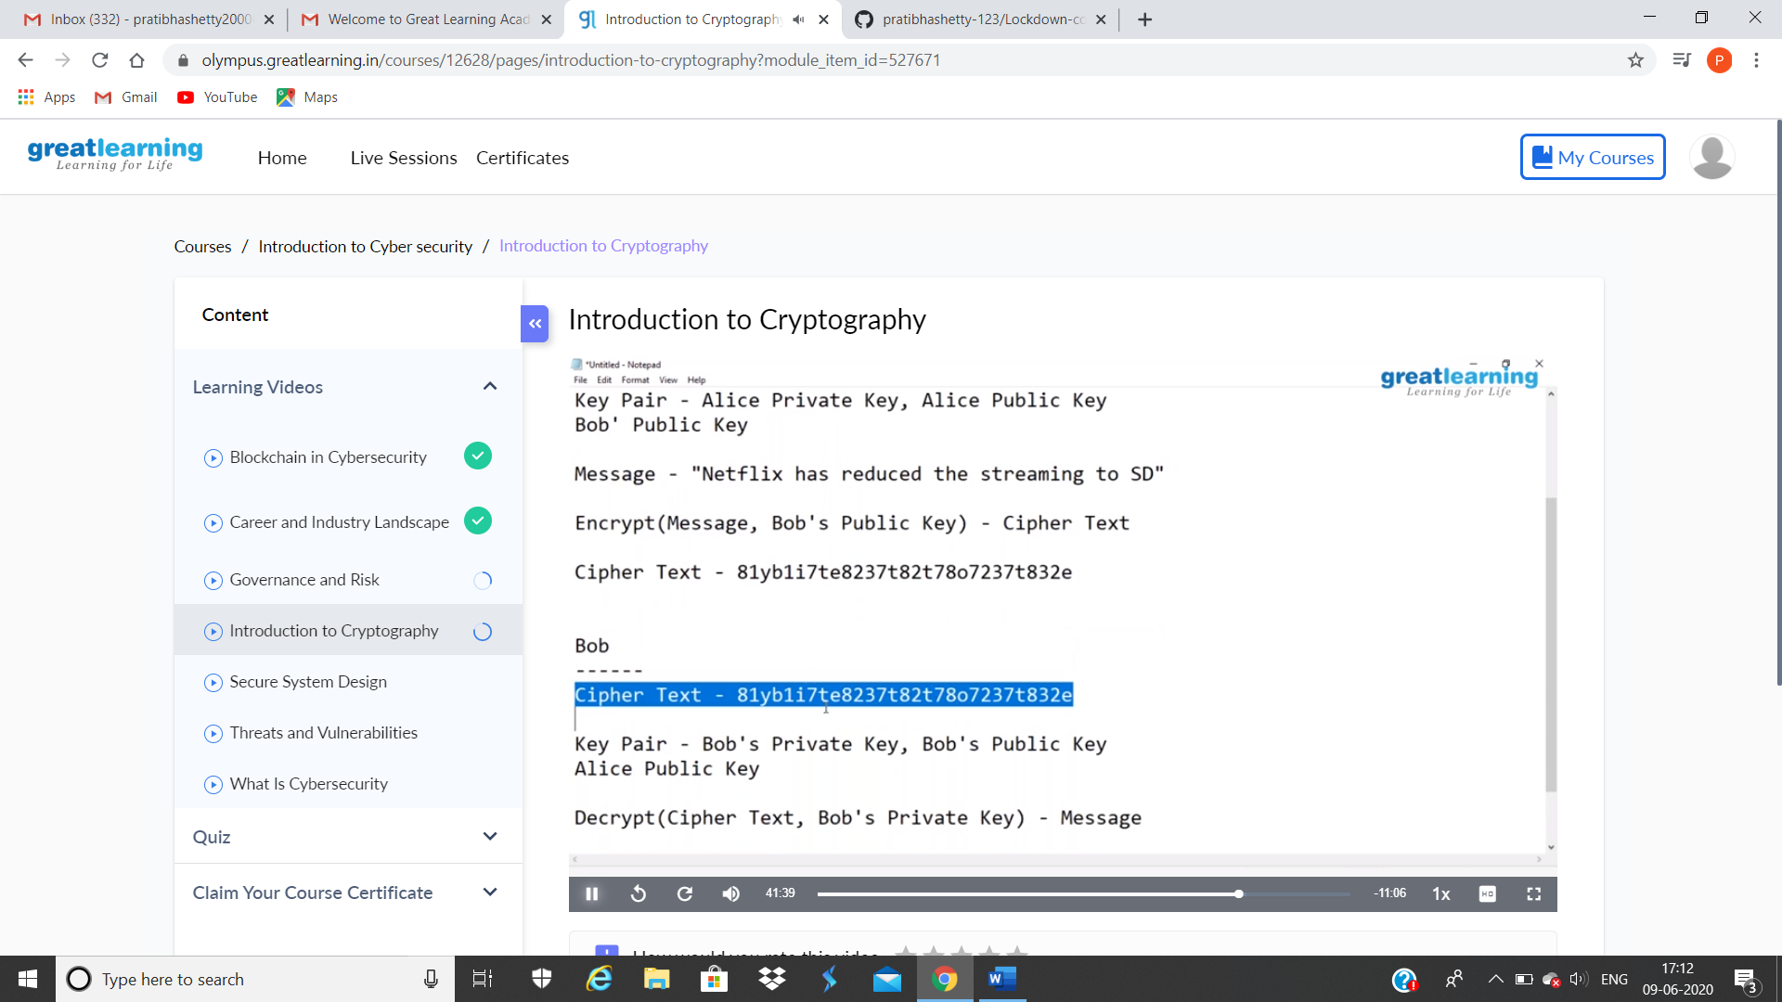

This is the snap shots of today’s sessions.

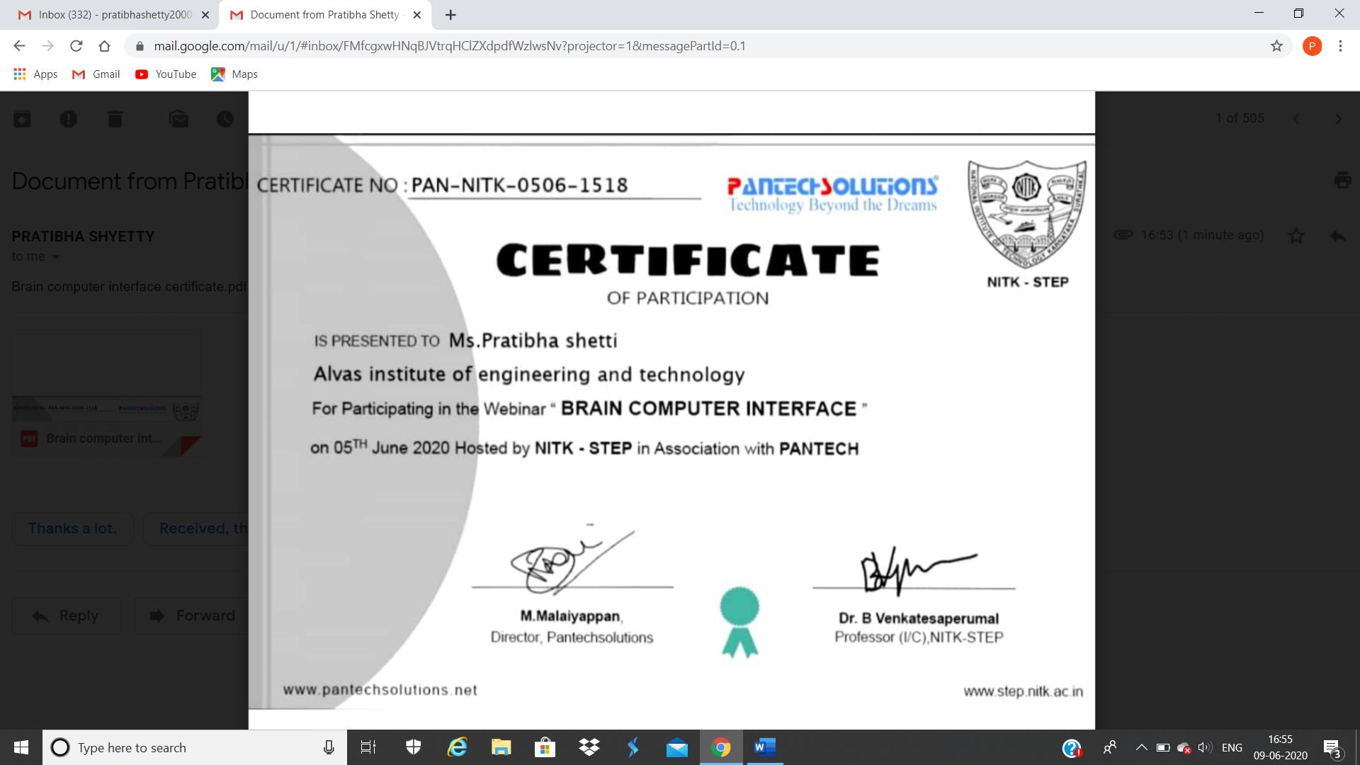

This is the snap shot of certificate for attending the “Brain computer Interface” section on 5th june

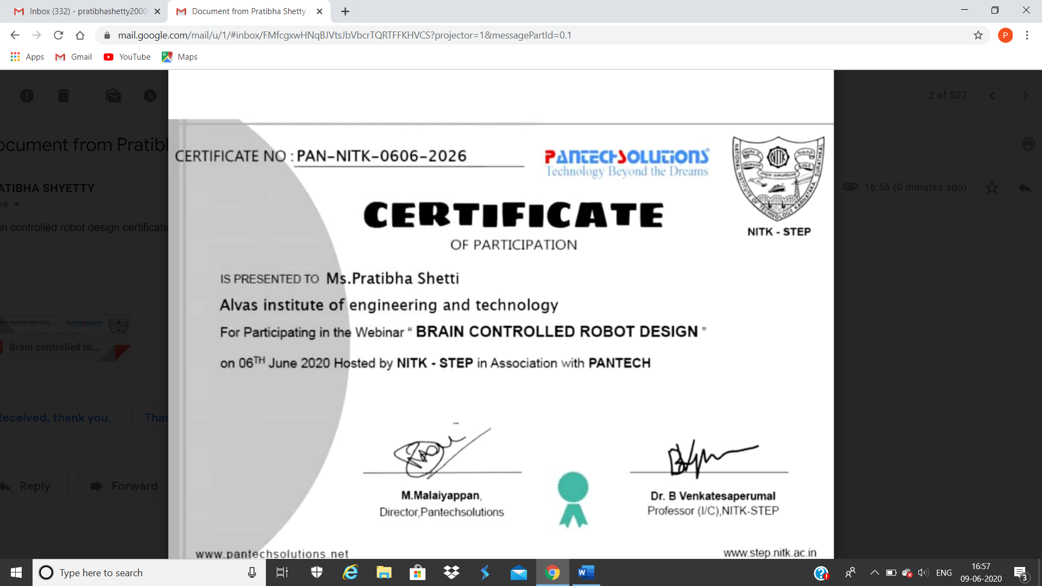

This is the snap shot of certificate for attending the “Brain controlled Robot design” section on 6th june

Online Coding Summary: **Today I had received one program from prof.Venkatesh CSE Dept. The program is mentioned above in the coding challenges(pg.01). I have also uploaded it to my Github repository.**

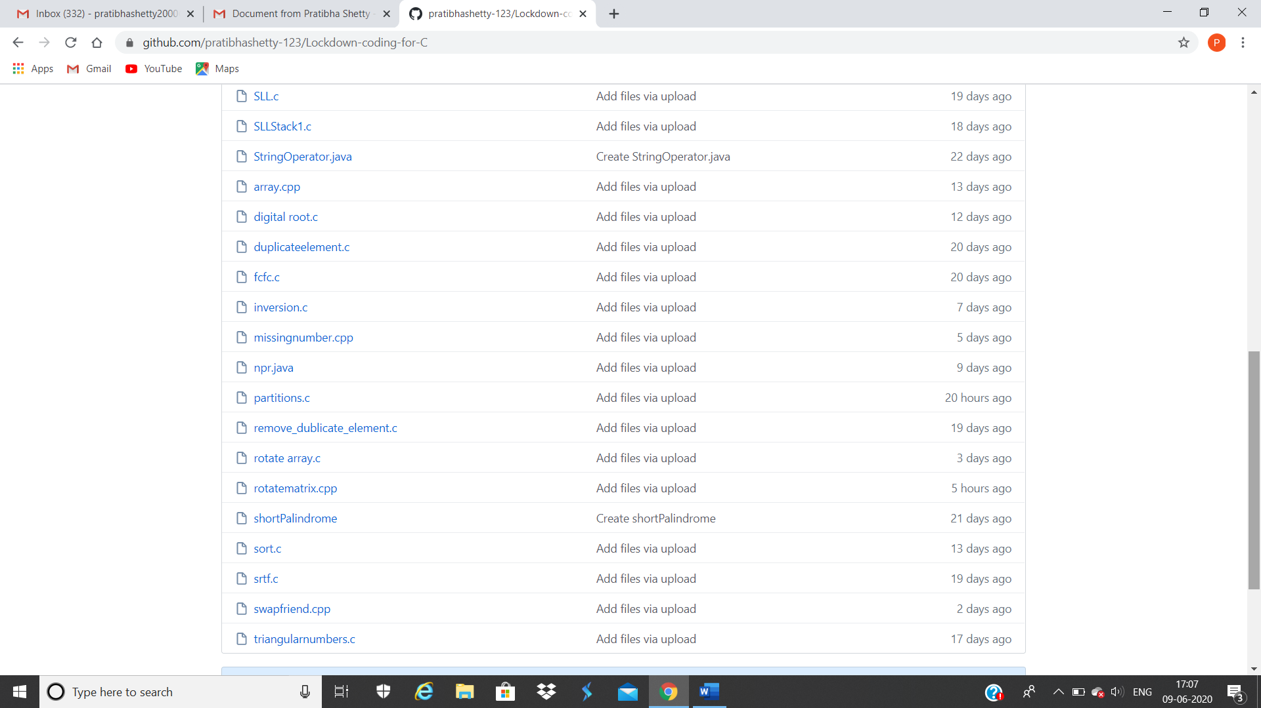**This is the snap shot of my repository** were I have uploaded the code. File name is rotationmatrix.cpp